**WIA2001/WIB2001**

**DATABASE**

**SEM 1, 20116/2017**

**MUHAMMAD AZRI BIN ZAINUDDIN WER150018**

**Tutorial 1**

1. Explain the difference between data and information.

Data – raw data that have been processed, there is no meaning behind those data

Information – processed data that have meaning to help in making good decision and create knowledge

1. What is data redundancy, and which characteristics of the file system can lead to it?

Data redundancy – unnecessarily storing the same data at different places. Example, storing customers’ information in two departments

1. What are the main components of a database system?
2. End-user data: raw facts of interest to end user
3. Metadata: data about data, describing data characteristics and relationships
4. Describe the five types of users identified in a database system.
5. System administrators – oversee the database system’s general operations
6. Database administrators (DBA) – managing the database management system and ensure that the database is functioning properly
7. Database designers – design the database structure, also known as the database architects
8. System analysts and programmers – design and implement the application programs, designing and creating the data entry screens, reports and procedures through which end users access and manipulate the database’s data’
9. End users – the people who use the application programs to run the organization’s daily operations
10. Answer the following questions :

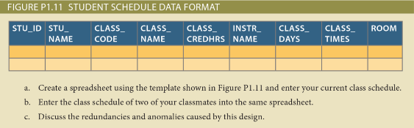

a) and b) answers are in the spreadsheet

1. Redundancies: inserting the data of class code, class name, class credithours, instructors’ name, class days, class times and room

Anomalies:  
  
Update anomaly: if the class time or class day is changed, all three records need to be updated

Deletion anomaly: If the class is no longer exist, deleting the data related to class will resulting the loss of students’ data, which is unintended.